**Apache Maven**

**Step 1** : go through this link - <https://maven.apache.org/>

**Step 2** : click on download

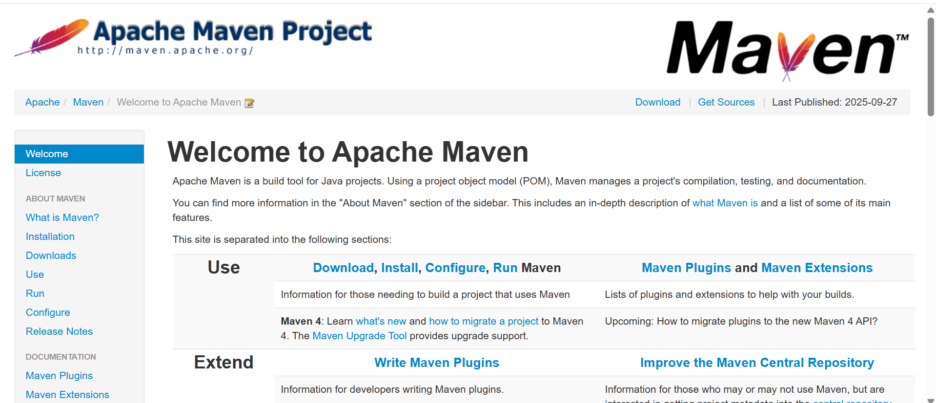

**Step 3** : scroll down and click on Binary zip archive link, then download is starting

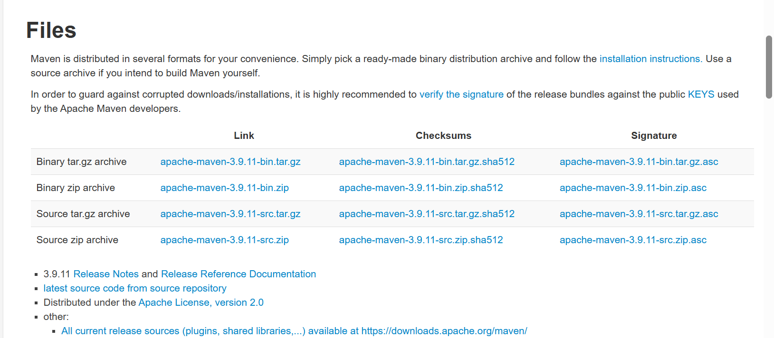

**Step 4** : after downloading zip file, extract this zip file and copy the folder which name is **apache-maven-3.9.11** and paste it into **C:\Program Files** thispath. And open bin folder in **apache-maven-3.9.11** folder and copy the path of that bin folder.

**Step 5** : Open edit system environment variable and click on Environment variables option after that double click on path option in system variables

**Step 6** : Then edit environment variable window is open then click on new button and paste the copied path of bin folder in there. Then click on ok and again click on ok and again click on ok.

**Step 7** : For cross verification open cmd and type **mvn –version** and hit enter button. You can see the current version of maven

